Experiment-2
Vibration transmissibility of a single-degree-of-freedom system
Group No. - B6 Date – 06/08/2006
Shift – 10:00-11:30………….. 11:30-1:00……✔………
Name | Roll No.
Atharv Patil | 240740

Overview
This experiment investigates the response of a single degree of freedom (SDOF) system mounted on a base, which is excited by a motor generating a sinusoidal displacement of constant amplitude. The masses are constrained to move only in the vertical direction. Its acceleration is measured using a piezoelectric accelerometer. The sensor is connected to a charge amplifier, which in turn is connected to an oscilloscope that displays motion in terms of voltage. This voltage can then be converted into displacement in millimeters.

Objective
Our objective is to study the transmissibility of vibrations from the base to the mass. To achieve this, we record the vibration amplitude of the mass at various base excitation frequencies.
Experimental procedure:
- The base displacement amplitude is about 6.35 mm peak to peak. Verify the amplitude by attaching the sensor to the base. You can convert the signal on the oscilloscope (which is in volts) to mm by multiplying it by a suitable factor.
- Put the piezo sensor on the mass ‘m1’ and measure the displacement for the frequency range of 5 to a maximum of 35 Hz (do not go beyond 35 Hz in any case). Take about 20 readings. Be careful to take only small increments and to let the system settle down for a while after each increment. Take several readings close to the resonant frequency.
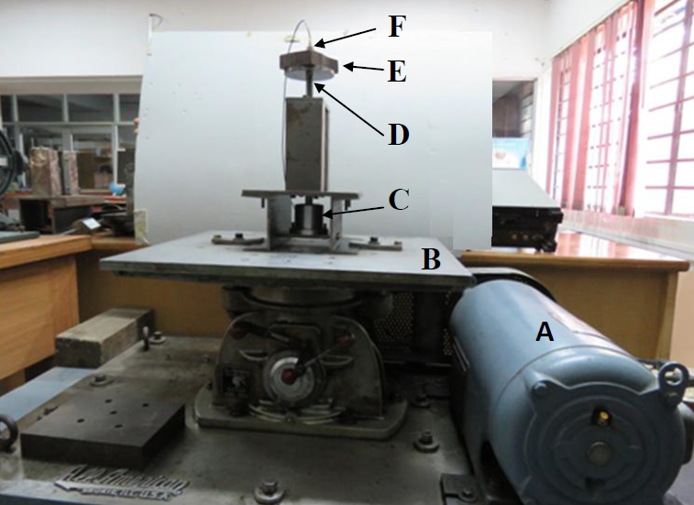
Fig. 1 Experiment setup. (A) Motor (B) Base (C) Viscous damper (D) Primary mass system (E) Added extra mass (F) Piezo sensor.

- Attach the known extra mass ‘m2’ 1.75 kg, over ‘m1’ 4.8 kg. Repeat step 2 for the combined system within the same frequency range.
- Remove the viscous fluid from the damper pot through a suction syringe (this removes the damping). Repeat step 2 for the combined system as mentioned in step 3.
- Fill in the frequency-amplitude data for each step in the observation tables given below.
Values you will need
Weight of the extra mass = 1.1 Kg.
Displacement conversion from oscilloscope: 100 mV = 1mm
Observation tables:
SDOF System without damper and without extra mass

Data Point | 1 | 2 | 3 | 4 | 5 | 6 | 7 | 8 | 9 | 10
Frequency | 3.37Hz | 3.96Hz | 5.55Hz | 7.14Hz | 7.35Hz | 6.75Hz | 8.33Hz | 8.92Hz | 9.25Hz | 9.61Hz
Amplitude | 70.8mV | 84.0mV | 123.0mV | 143.0mV | 170.0mV | 212.0mV | 0.592V | 1.180V | 0.616V | 0.336V

SDOF System without damper and with extra mass

Data Point | 1 | 2 | 3 | 4 | 5 | 6 | 7
Frequency | 4.54Hz | 5.00Hz | 5.43Hz | 6.94Hz | 9.61Hz | 10.0Hz | 12.4Hz
Amplitude | 89.0mV | 131.0mV | 161.0mV | 0.644V | 196mV | 174.0mV | 164.0mV

Plots
- System without damper and without extra mass
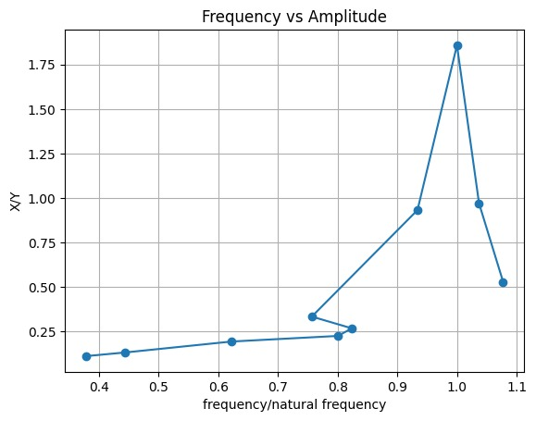

- System without damper and with extra mass
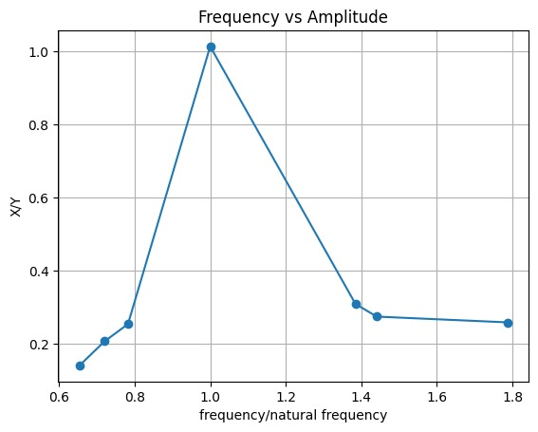

- Combined
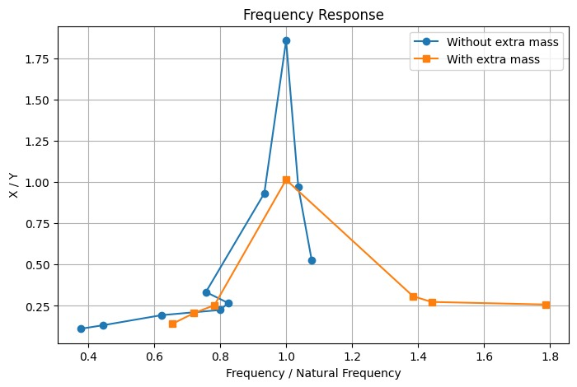

Observation
Observation1:
As the excitation frequency is increased, the amplitude of vibration first increases and reaches a maximum near the resonance region. After passing this region, the amplitude starts decreasing.
Observation2:
When the extra mass is added to the system, the resonance occurs at a lower frequency. In the readings, the peak response shifts from around 8.9 Hz for the original system to around 6.9 Hz after adding the extra mass.
Observation3:
The system with damping shows a smaller and broader resonance peak compared to the undamped system. This shows that the viscous damper reduces the vibration amplitude near resonance.
Observation4:
At frequencies sufficiently higher than the resonance region, the vibration amplitude decreases considerably. Hence, the mass motion becomes smaller compared with the base excitation, giving lower transmissibility.

Calculation of Original Mass (m):
The transmissibility is given by Eq. (10),
T = |X/Y| = √[(k² + (cω)²) / {(k − mω²)² + (cω)²}]
For T = 1,
k² + (cω)² = (k − mω²)² + (cω)²
Therefore,
k² = (k − mω²)²
Taking the non-zero solution,
mω² = 2k
Hence,
ω = √(2k/m)
Since ω = 2πf,
f = (1/2π)√(2k/m)
For the original system,
f₁ = (1/2π)√(2k/m)
For the system with the additional mass M,
f₂ = (1/2π)√[2k/(m + M)]
Dividing the two equations,
f₁²/f₂² = (m + M)/m
Therefore,
f₁²m = f₂²(m + M)
f₁²m = f₂²m + f₂²M
m(f₁² − f₂²) = f₂²M
Thus,
m = (M f₂²)/(f₁² − f₂²)
Given,
M = 1.105 kg
The base displacement is 6.35 mm peak-to-peak. Therefore, the displacement amplitude is Y = 6.35/2 = 3.175 mm
Using the oscilloscope conversion,
100 mV = 1 mm
Therefore,
Y = 3.175 × 100 = 317.5 mV
Hence, T = 1 corresponds to an amplitude of 317.5 mV.

1. Frequency f₁ for the original system:
From the recorded data, the descending part of the curve is
At 9.25 Hz, amplitude = 616 mV
At 9.61 Hz, amplitude = 336 mV
The required amplitude is 317.5 mV, which is slightly below 336 mV. Therefore, the frequency is estimated by linear extrapolation.
f₁ = 9.61 + [(317.5 − 336)/(336 − 616)](9.61 − 9.25)
f₁ = 9.61 + [−18.5/(−280)](0.36)
f₁ = 9.61 + 0.0238
f₁ ≈ 9.634 Hz

2. Frequency f₂ for the system with extra mass:
From the recorded data,
At 6.94 Hz, amplitude = 644 mV
At 9.61 Hz, amplitude = 196 mV
The required amplitude is 317.5 mV. Therefore, using linear interpolation,
f₂ = 6.94 + [(317.5 − 644)/(196 − 644)](9.61 − 6.94)
f₂ = 6.94 + [−326.5/(−448)](2.67)
f₂ = 6.94 + 1.945
f₂ ≈ 8.885 Hz
Now, m = (M f₂²)/(f₁² − f₂²)
Substituting,
m = [1.105 × (8.885)²] / [(9.634)² − (8.885)²]
m = [1.105 × 78.944] / [92.814 − 78.944]
m = 87.231 / 13.870
m ≈ 6.29 kg
Therefore, the estimated original mass of the SDOF system is m ≈ 6.29 kg

